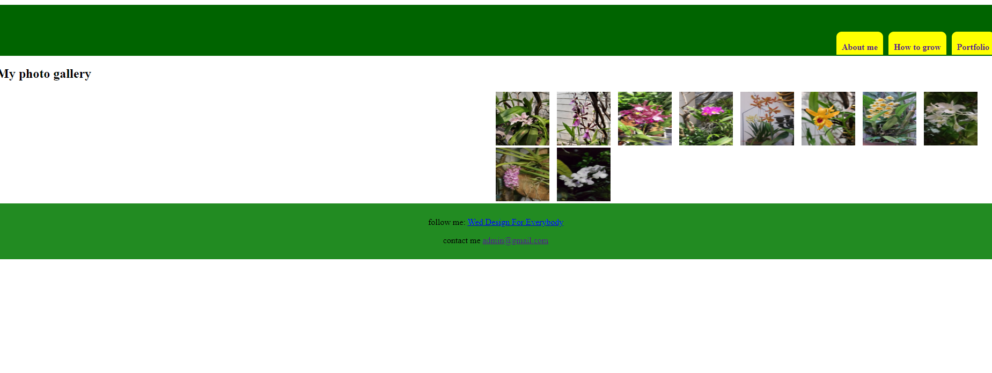

1. hover Image then change background image of div
2. Check if email is empty, change background of input email to “red”.

If nothing to checked, then show mess “must least one radio checked”

If content isn’t start with “hello”, show mess “content must be start with hello”

Else show mess “information sent”

When user click ok button -> reset form

